**Food Ordering System**

**Report**

**Group Number: 71**

**1. INTRODUCTION**

**1.1 Overview**

The Ecommerce Online Shopping project aims to develop a web application using React JS for the frontend, Spring Boot for the backend, and MySQL for the database. The project focuses on creating a platform for users to browse and purchase products online, providing a seamless and intuitive shopping experience.

**1.2 Purpose**

The purpose of this project is to build an efficient and user-friendly ecommerce website that allows customers to explore a wide range of products, add them to their cart, make secure payments, and track their orders. The project enables businesses to showcase their products online, manage inventory, and process customer orders effectively. Additionally, it provides administrators with tools to manage products, users, and orders.

**2. LITERATURE SURVEY**

**2.1 Existing problem**

The ecommerce industry has witnessed significant growth over the years, leading to increased competition. Existing ecommerce platforms often face challenges such as poor user experience, limited features, and scalability issues. These problems can negatively impact customer satisfaction and hinder business growth.

**2.2 Proposed solution**

To address the existing problems, the proposed solution combines React JS, a powerful frontend library for building dynamic user interfaces, with Spring Boot, a robust Java framework for developing scalable and efficient backend systems. MySQL, a widely used relational database, is employed to store and retrieve data related to products, users, and orders.

The integration of these technologies enables the development of a responsive and interactive ecommerce platform that offers a wide range of features, including product catalog browsing, user registration and authentication, shopping cart management, secure payment processing, order tracking, and administrative functionalities.

**3. THEORETICAL ANALYSIS**

**3.1 Hardware / Software designing**

The Ecommerce Online Shopping project requires the following hardware and software components:

Hardware Requirements:

A computer system with sufficient processing power and memory to run the development environment.

Reliable internet connectivity to access online resources and facilitate interactions with the application.

Software Requirements:

Node.js: A JavaScript runtime environment required to execute React JS applications.

Text editor or IDE: To write code and manage project files.

Web browser: To preview and test the application.

Spring Tool Suite: An integrated development environment (IDE) for developing Spring Boot applications.

MySQL: A relational database management system to store and retrieve application data.

**4. EXPERIMENTAL INVESTIGATIONS**

During the development of the Ecommerce Online Shopping project, several investigations and analyses were conducted. These include:

User interface design: Iterative design and development of intuitive and visually appealing user interfaces to enhance user experience.

API integration: Integration of third-party APIs for secure payment processing, order tracking, and other external services.

Performance optimization: Identification and optimization of bottlenecks to improve application speed and responsiveness.

Testing and bug fixing: Rigorous testing and debugging to ensure the application functions correctly and meets user requirements.

1. **RESULT**

The Ecommerce Online Shopping project has successfully been implemented, resulting in the following findings:

A fully functional ecommerce website with an intuitive user interface.

Seamless browsing and searching of products within the catalog.

Secure user registration and authentication mechanisms.

Efficient shopping cart management with the ability to add, remove, and update items.

Secure payment processing through integration with a trusted payment gateway.

Order tracking functionality for users to monitor their purchases.

Administrative features for managing products, users, and orders.

Screenshots:

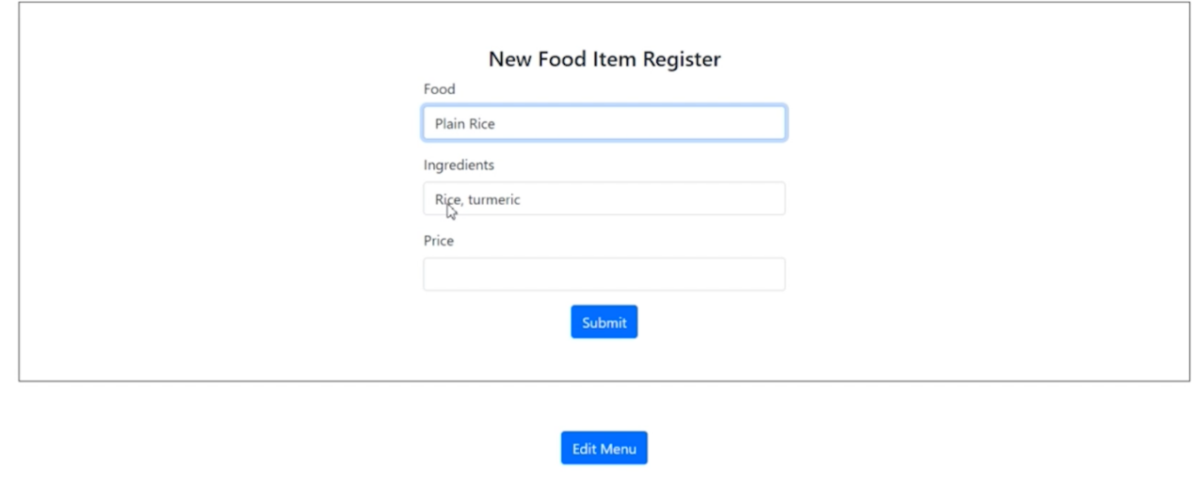

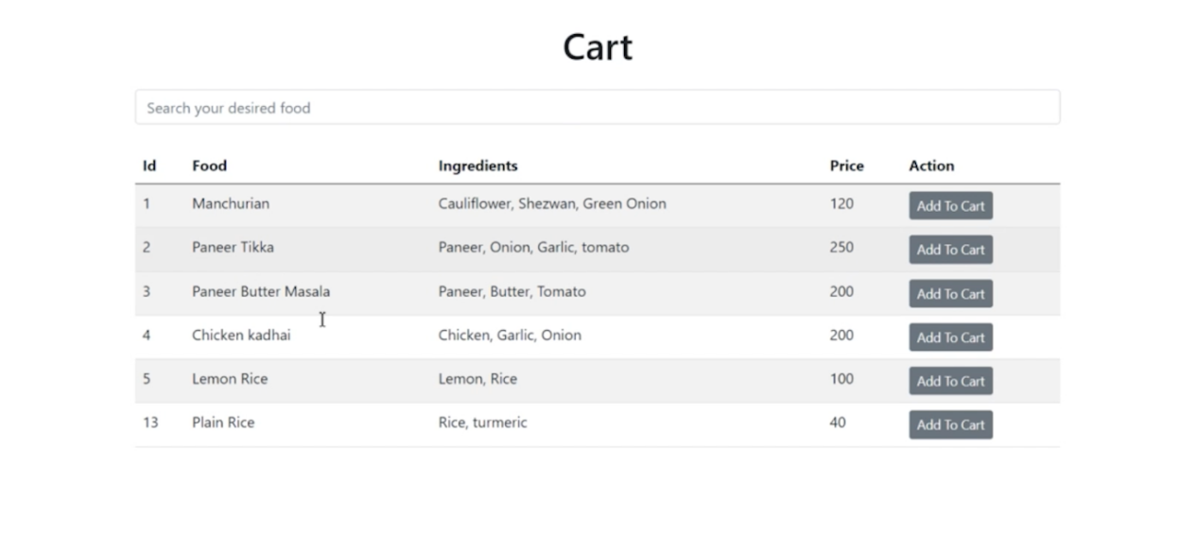

**6. ADVANTAGES & DISADVANTAGES**

Advantages:

Improved user experience and interface design.

Enhanced scalability and performance.

Secure payment processing and order management.

Effective product catalog management.

Streamlined administrative functionalities.

Increased customer satisfaction and conversion rates.

Disadvantages:

Initial development and setup may require time and resources.

Maintenance and ongoing updates may be necessary to address evolving requirements and security concerns.

Integration with third-party APIs may introduce dependencies and potential compatibility issues.

1. **APPLICATIONS**

The proposed solution can be applied in various scenarios, including:

Retail businesses seeking to establish an online presence and expand their customer base.

Startups looking to develop and launch an ecommerce platform quickly and efficiently.

Existing ecommerce platforms aiming to improve user experience, scalability, and security.

**8. CONCLUSION**

In conclusion, the Ecommerce Online Shopping project successfully demonstrates the development of an ecommerce platform using React JS, Spring Boot, and MySQL. The project addresses existing problems in the ecommerce industry by providing a user-friendly interface, robust backend functionality, and secure transaction processing. The project achieves its purpose of enabling customers to shop conveniently online and businesses to effectively manage their products and orders.

1. **FUTURE SCOPE**

The project's future scope includes the following enhancements:

Integration with additional payment gateways to offer more options to users.

Implementation of personalized recommendations based on user browsing and purchase history.

Integration with social media platforms for enhanced marketing and customer engagement.

Implementation of advanced inventory management features, such as automated stock updates and alerts.

Expansion to include mobile applications for a seamless shopping experience across multiple devices.

Integration with customer support and chatbot systems to provide real-time assistance to users.